
GALGOTIAS UNIVERSITY
Plot No.2, Sector 17-A, Yamuna Expressway, Greater Noida, Gautam Buddh Nagar, U.P., India

School of Basic and Applied Sciences
(Division of Mathematics)

Lab Report Exploration with CAS-I

B.Tech. (First Sem.2021-2022)

Submitted by: Submitted to:
S. No. | List of Experiments
1. | Overview, Basic syntax, Mathematical Operators, Predefined constants, Built in functions at SCILAB platform.
2. | Write a SCILAB code to find addition, subtraction, multiplication and division of two matrices , transpose of a matrix and inverse of a non singular matrix.
3. | Write a SCILAB code for programming -Functions - Loops - Conditional statements - Handling .sci files.
4. | Write a SCILAB code for 2-D : circle, parabola, ellipse and hyperbola and 3-D surfaces: Planes, Sphere, Cylinder, Paraboloid, Ellipsoid, Hyperboloid, cone.
5. | Write a SCILAB code to find expansion of functions in Taylor series.
6. | Write a SCILAB code for Fourier series expansion of different wave forms and comparison with the original function.
7. | Write a SCILAB code for identifying the critical points of 2-D and 3-D. surface.
8. | Write a SCILAB code for computing double integrals in Cartesian coordinates.
9. | Write a SCILAB code for computing triple integrals in Cartesian coordinates.  .
10. | Write a SCILAB code for computing and plotting grad of scalar point function
11. | Write a SCILAB code for computing and plotting divergence of vector point functions.
12. | Write a SCILAB code for computing and plotting curl of Vector point functions.

 | S. No. | Experiment | Date  (Scheduled) | Date  (Performed) | Faculty  Signature (with date)
 | 1. | Introduction to Scilab and  Develop SCILAB -CODE for plotting Exponential, Logarithmic, Trigonometric functions. | 2/11/2021 | 2/11/2021
 | 2. | SCILAB -CODE for find addition, subtraction, multiplication and division of two matrices, transpose of a matrix and inverse of a non singular matrix. | 9/11/2021 | 9/11/2021
 | 3. | SCILAB -CODE for programming -Functions – Loops – Conditional statements – Handling .sci files. | 30/11/2021 | 30/11/2021
 | 4. | SCILAB -CODE for 2-D : circle, parabola, ellipse and hyperbola and 3-D surfaces: Planes, Sphere, Cylinder, Paraboloid, Ellipsoid, Hyperboloid, cone. | 7/12/2021 | 7/12/2021
 | 5. | SCILAB -CODE to find expansion of functions in Taylor series. | 4/1/2022 | 4/1/2022
 | 6. | SCILAB -CODE for Fourier series expansion of different wave forms and comparison with the original  function. | 11/1/2022 | 11/1/2022
 | 7. | SCILAB -CODE for identifying the critical points of 2-D and 3-D. surface.
 | 8. | SCILAB -CODE for computing double integrals in Cartesian coordinates.
 | 9. | SCILAB -CODE for computing triple integrals in Cartesian coordinates.
 | 10. | SCILAB –CODE for computing and plotting grad of scalar point function .
 | 11. | SCILAB –CODE for computing and plotting divergence of vector point functions.
 | 12. | SCILAB –CODE for computing and plotting curl of Vector point functions.

EXPERIMENT-1

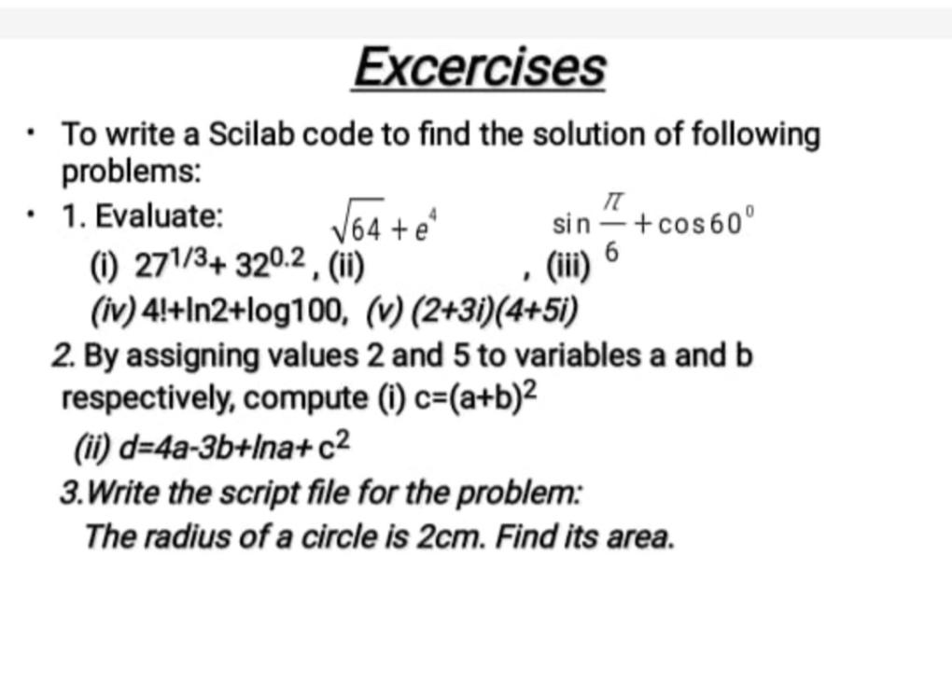

EXPERIMENT-1

1.(i) > 27^(1/3) + 32^0.2

(ii) > 64^(1/2) + (%e)^4

(iii) > sin(%pi/6) + cosd(60)

(iv) > factorial(4)+log(2)+log10(100)

(v) > (2+3*%i)*(4+5*%i)

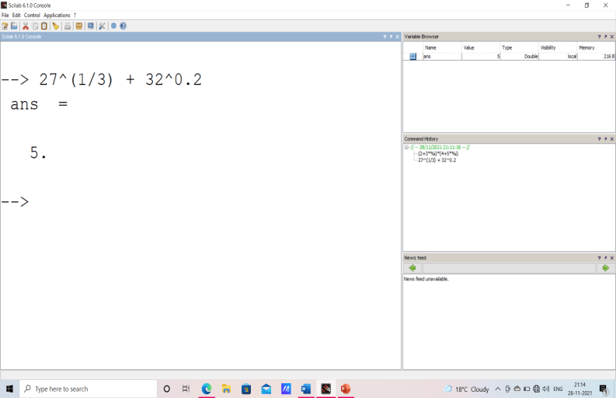
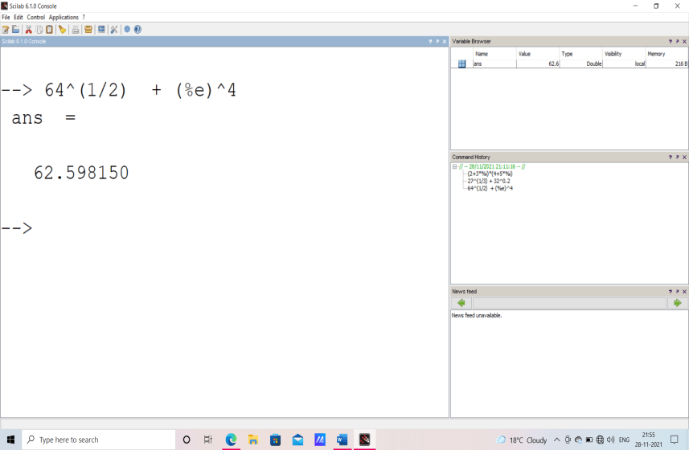

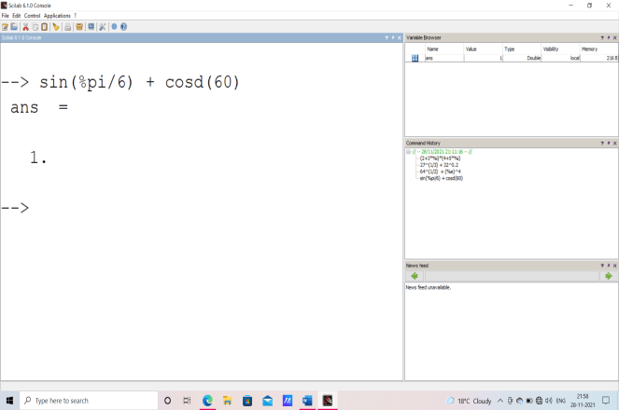
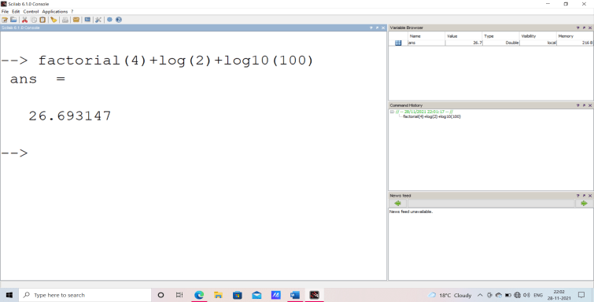
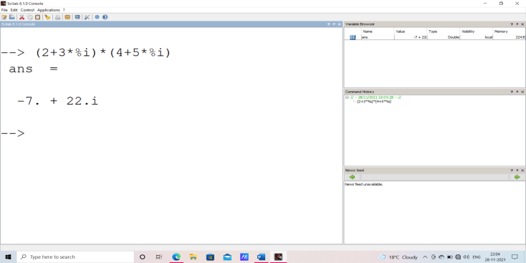

2.(i) a=2,b=5,c=(a+b)^2

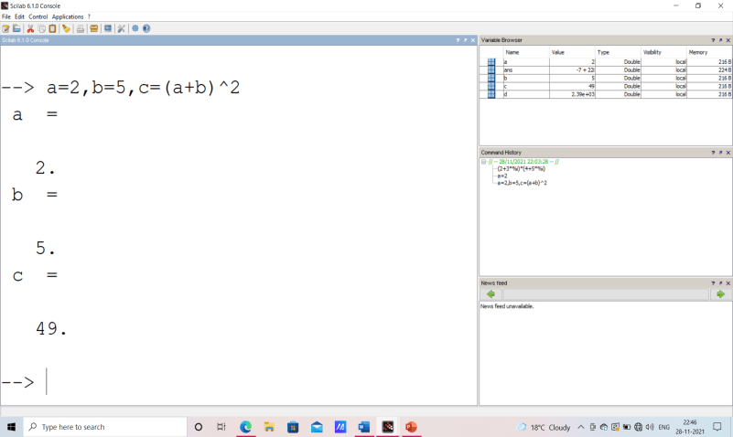

(ii) a=2,b=5,c=(a+b)^2,d=4*a-3*b+log(c)+c^2

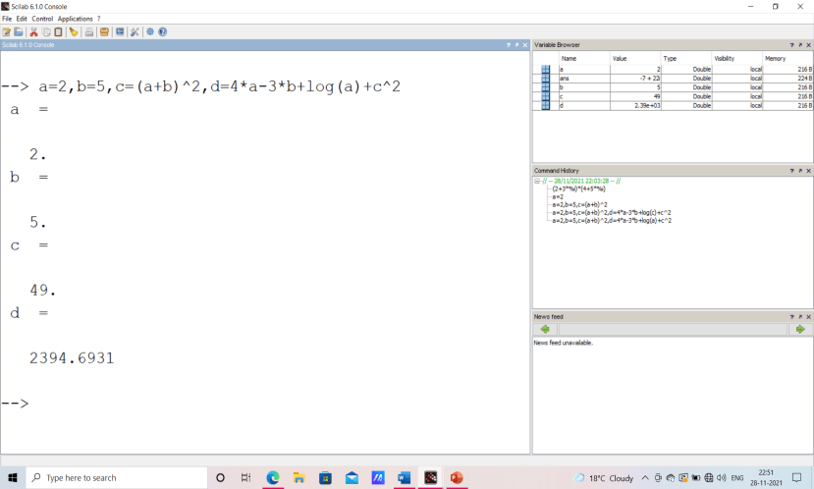

3.
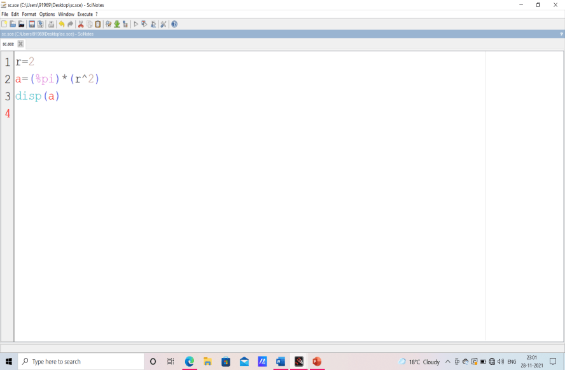

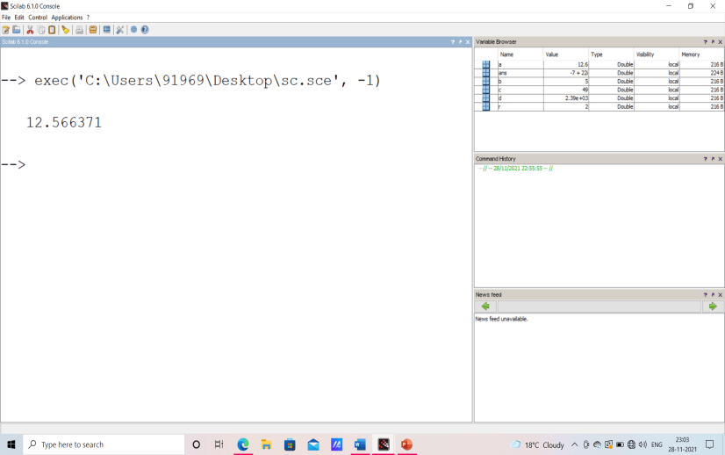

Experiment-2
Objective: Using Scilab for basic operations on matrices and finding determinant, inverse, Trace and rank of a matrix.
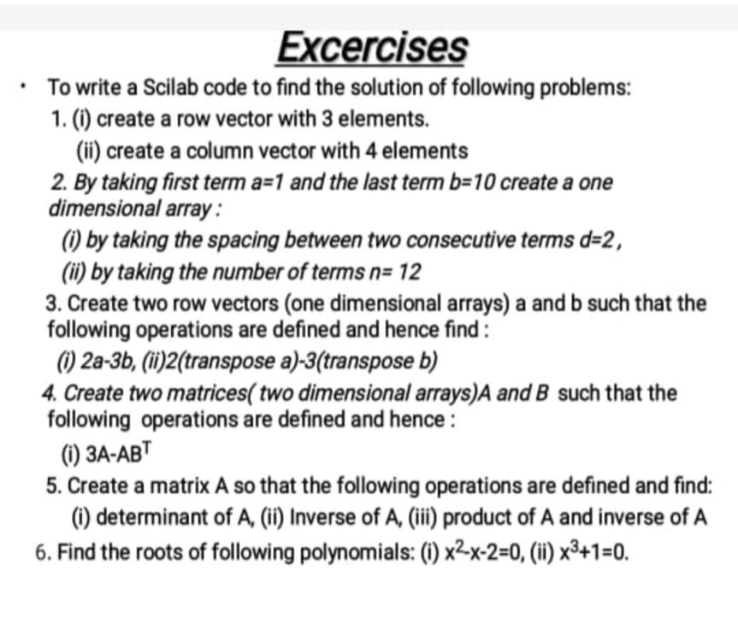

1.(i) INPUT
clc
clear
A= [2,-3,5]
disp(A)

OUTPUT

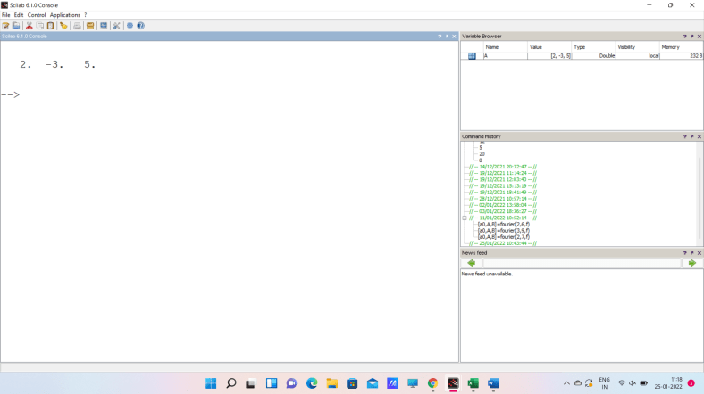

1.(ii) INPUT
clc
clear
A= [7;-3;5;6]
disp(A)

OUTPUT
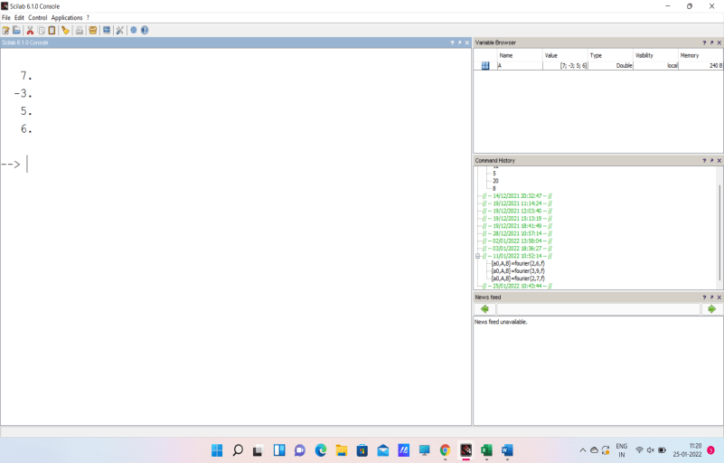

2.(i) INPUT
clc
clear
A= [1:2:10]
disp(A)

OUTPUT
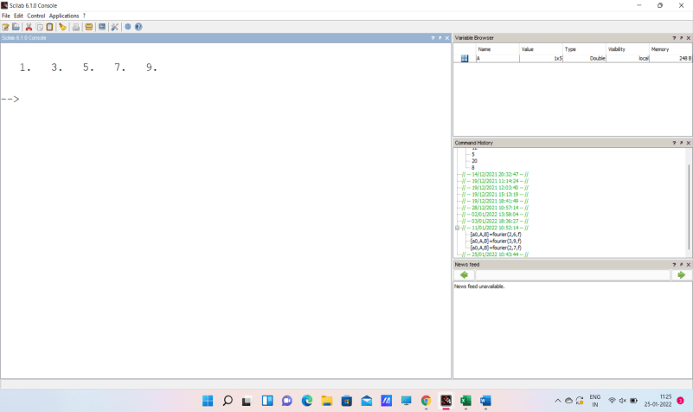

2.(ii) INPUT
clc
clear
A= linspace(1,10,12)
disp(A)

OUTPUT
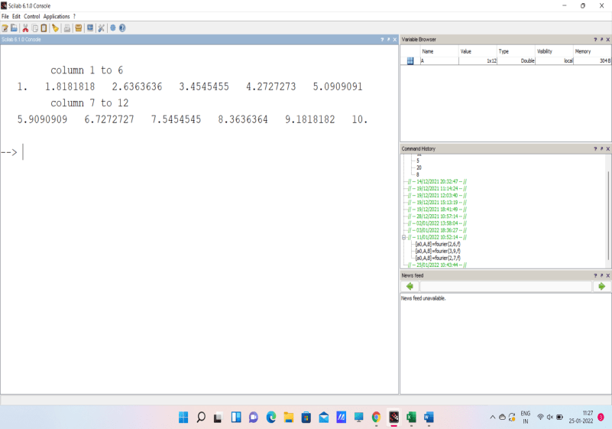

3.(i) INPUT
clc
clear
A=[1,2,3]
B=[4,5,6]
C=2*A-3*B
disp(C)

OUTPUT
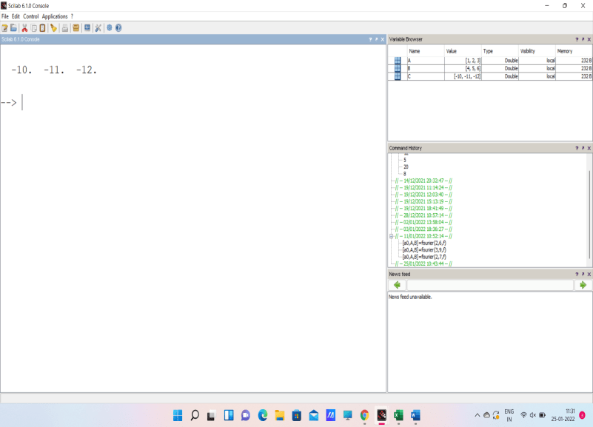

3.(ii) INPUT
clc
clear
A=[1,2,3]
B=[4,5,6]
C=2*A’-3*B’
disp(C)

OUTPUT

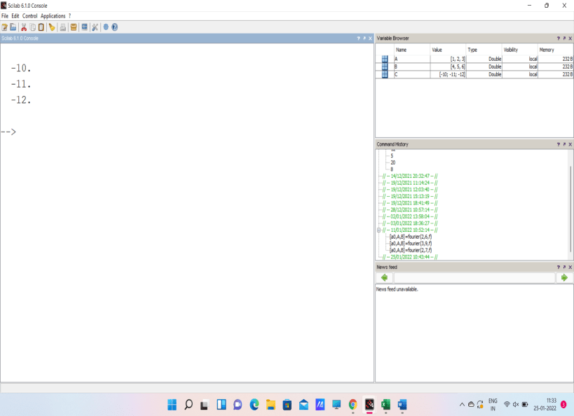

4.(i) INPUT
clc
clear
A= [1,2;3,4]
B= [4,5;6,7]
C=3*A-A*B’
disp(C)

OUTPUT
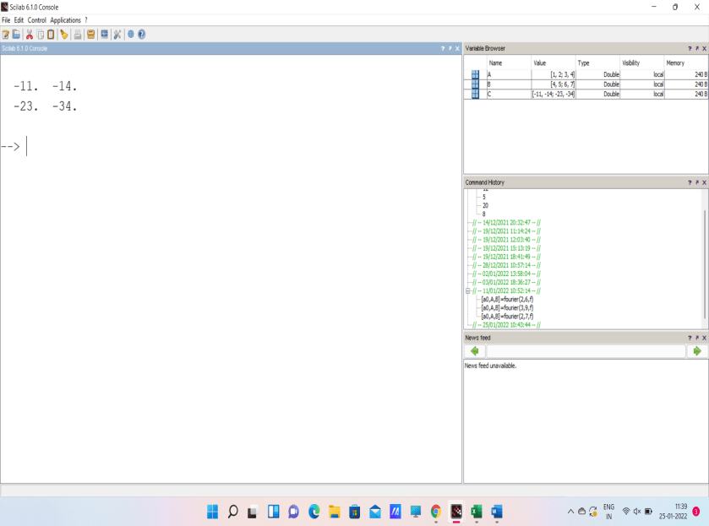

5.(i) INPUT
clc
clear
A=[8,4,3;-5,6,-2;7,9,-8]
B=det(A)
disp(B)

OUTPUT
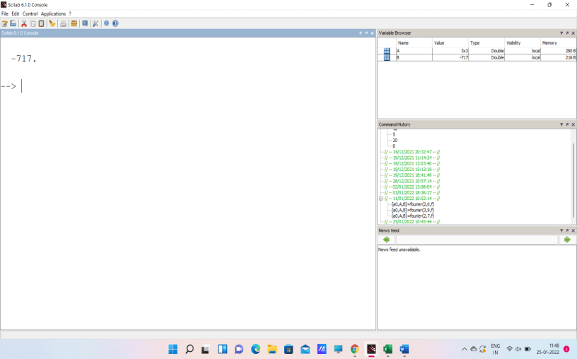

5.(ii) INPUT
clc
clear
A=[8,4,3;-5,6,-2;7,9,-8]
B=inv(A)
disp(B)

OUTPUT

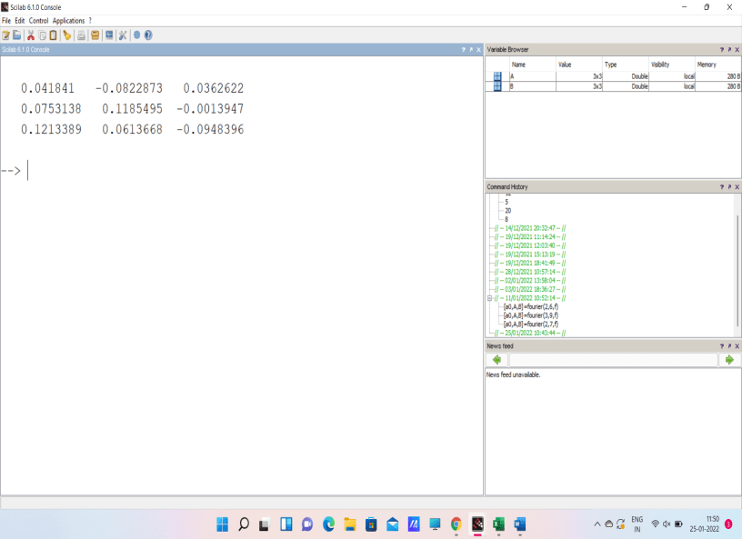

5.(iii) INPUT
clc
clear
A=[8,4,3;-5,6,-2;7,9,-8]
B=inv(A)
C=A*B
disp(C)

OUTPUT
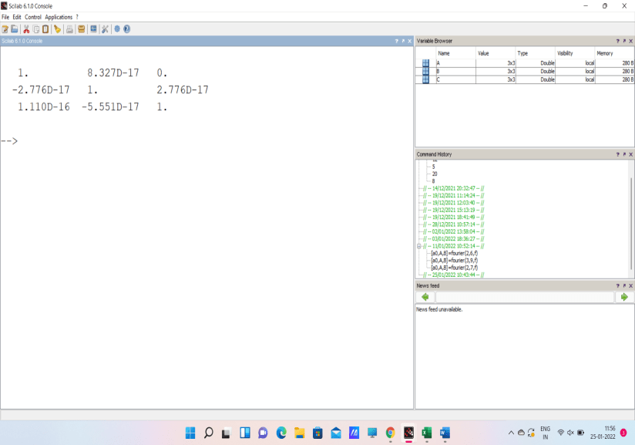

6.(i) INPUT
clc
clear
p=[1,-1,-2]
r=roots(p)
disp(r)

OUTPUT
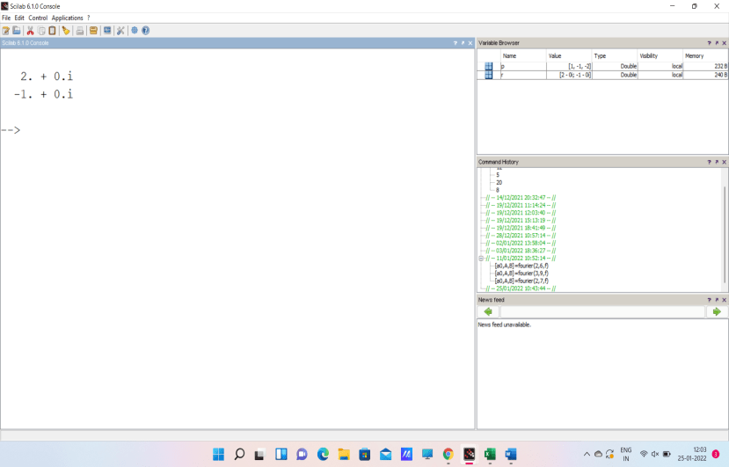

6.(ii) INPUT
clc
clear
p=[1,0,0,1]
r=roots(p)
disp(r)

OUTPUT
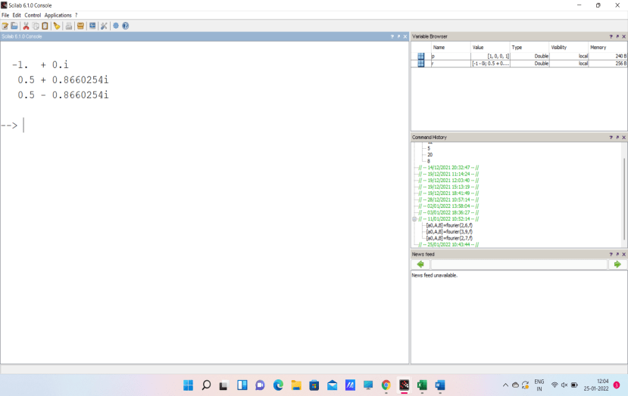

EXPERIMENT -3

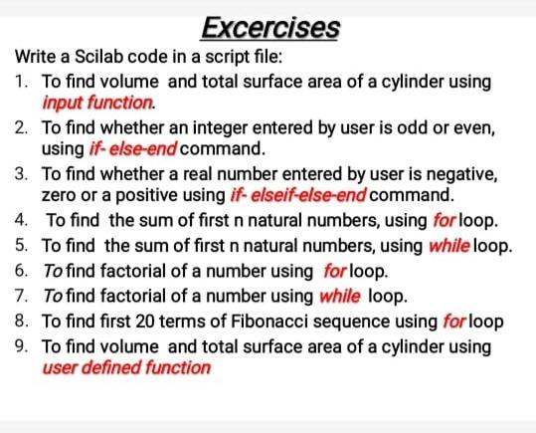

- INPUT

